Welcome to the official GameSimFall2016 GitHub repository guide.

IF YOU HAVENT COMPLETED “SettingUpTortoise.docx” YET, GO DO SO NOW.

This guide will teach you a few things:

1. How to checkout (pull) from an existing repository
2. How to add a document/folder to an existing repository
3. How to modify an existing document in an existing repository
4. How to commit(push) to an existing repository

**SECTION 1: Modifying an existing file:**

1. Go to your desktop, advanced users may choose a different destination folder location.

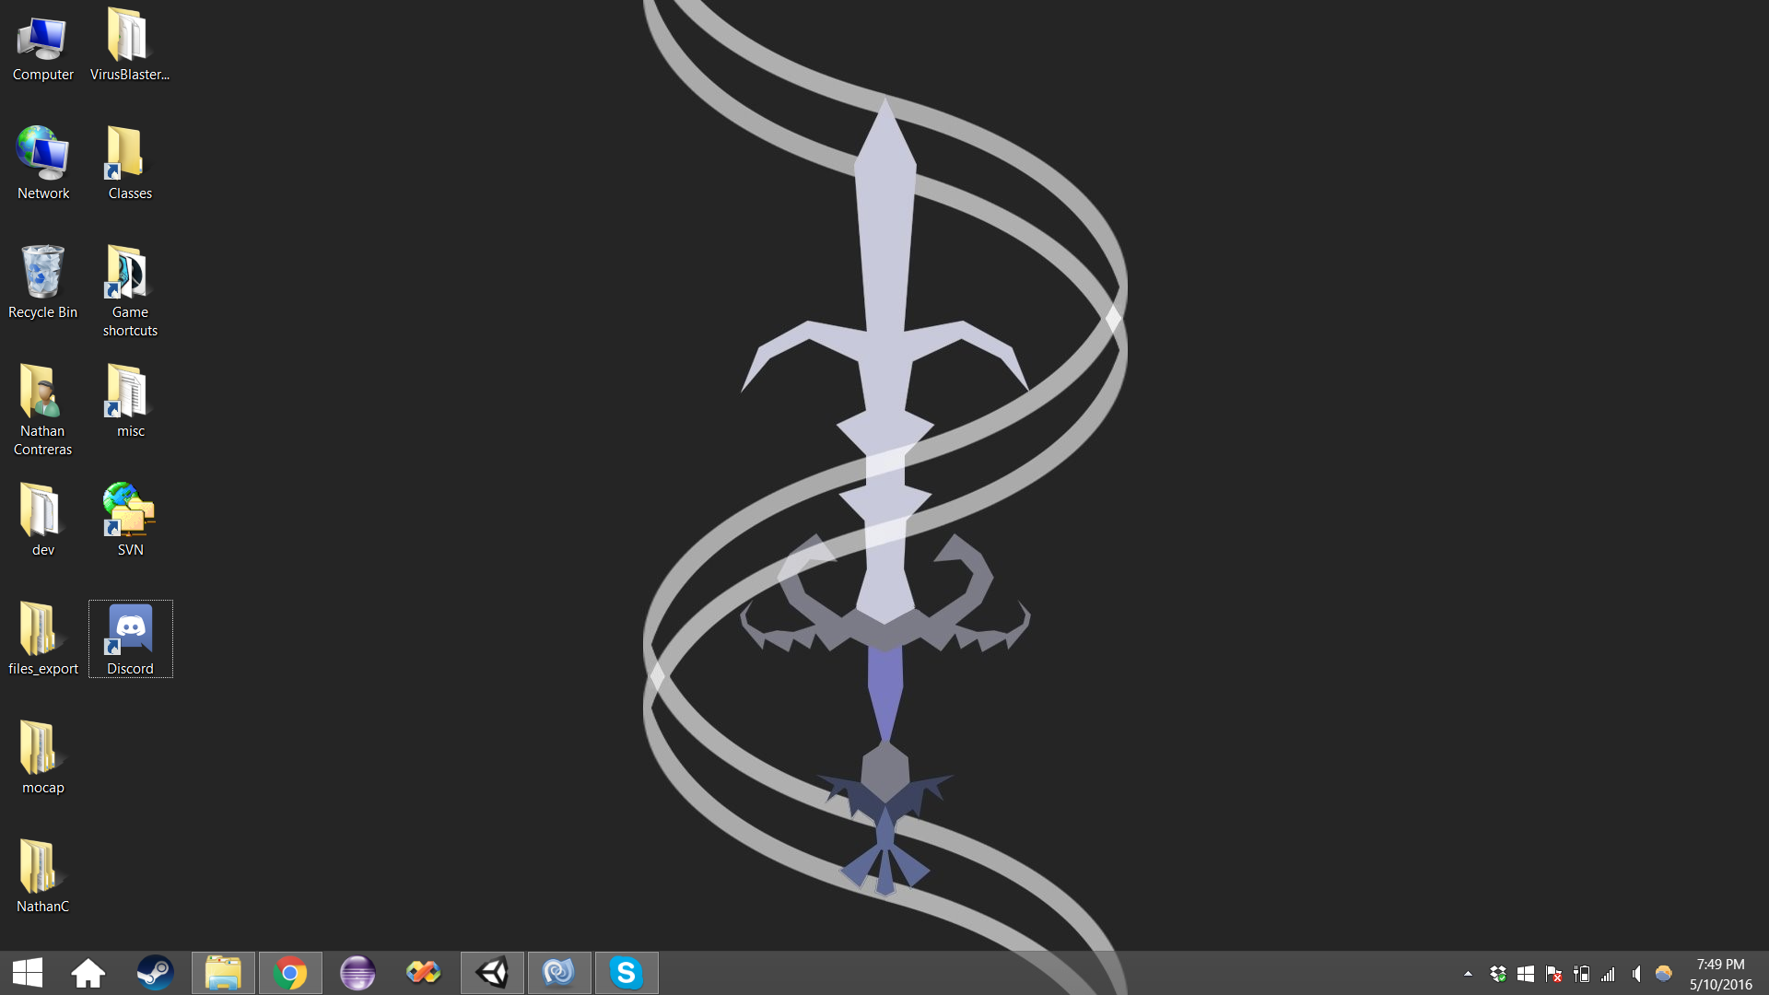

2. Right click your desktop, go to New, and select Folder.

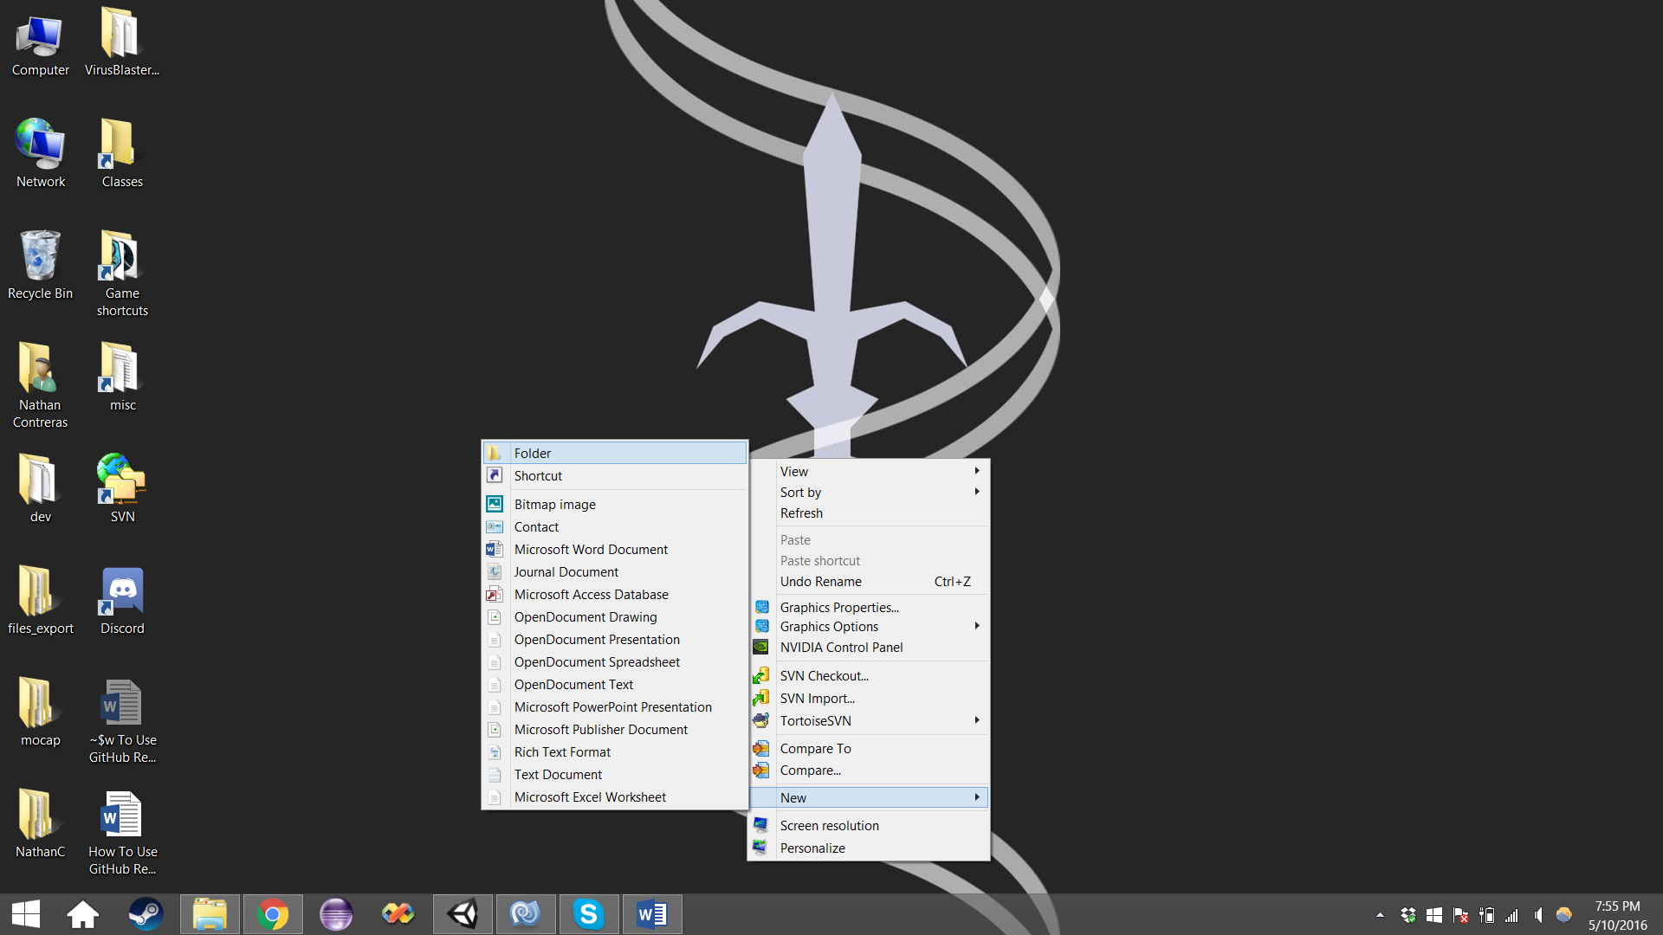

3. Name the folder something appropriate, such as “GameSim”. 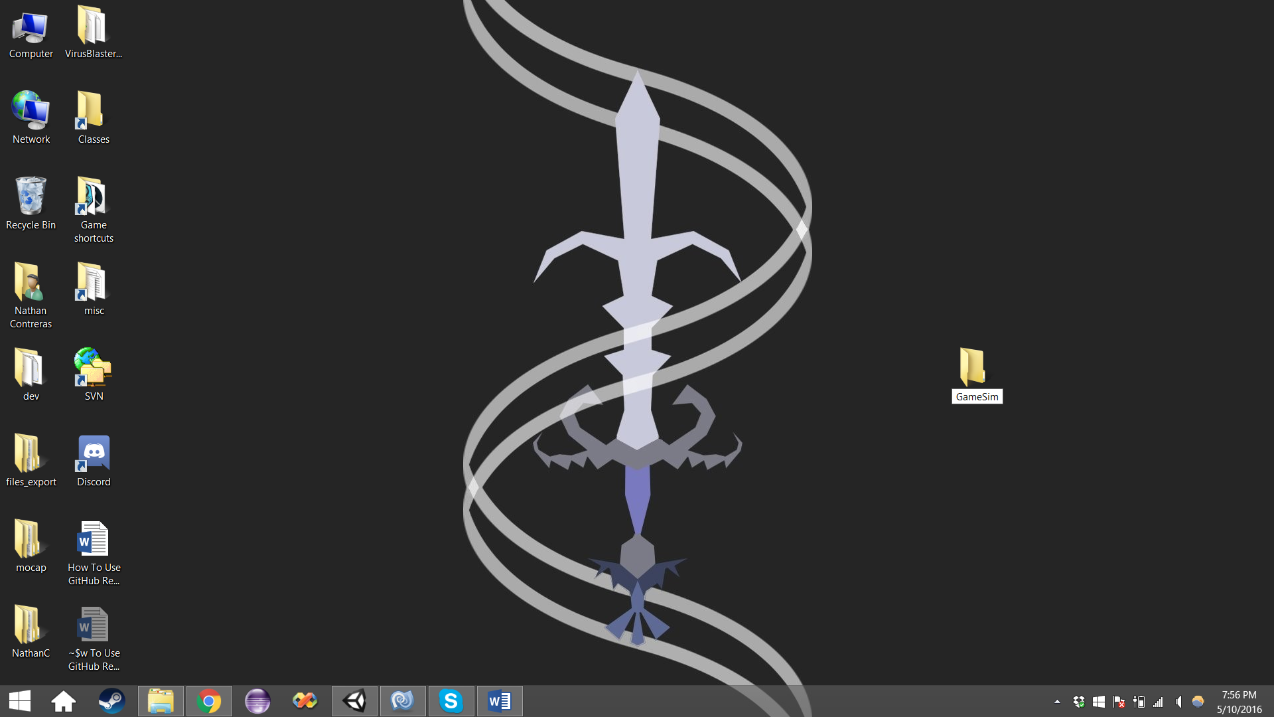

4. Right click the folder, and select SVN Checkout

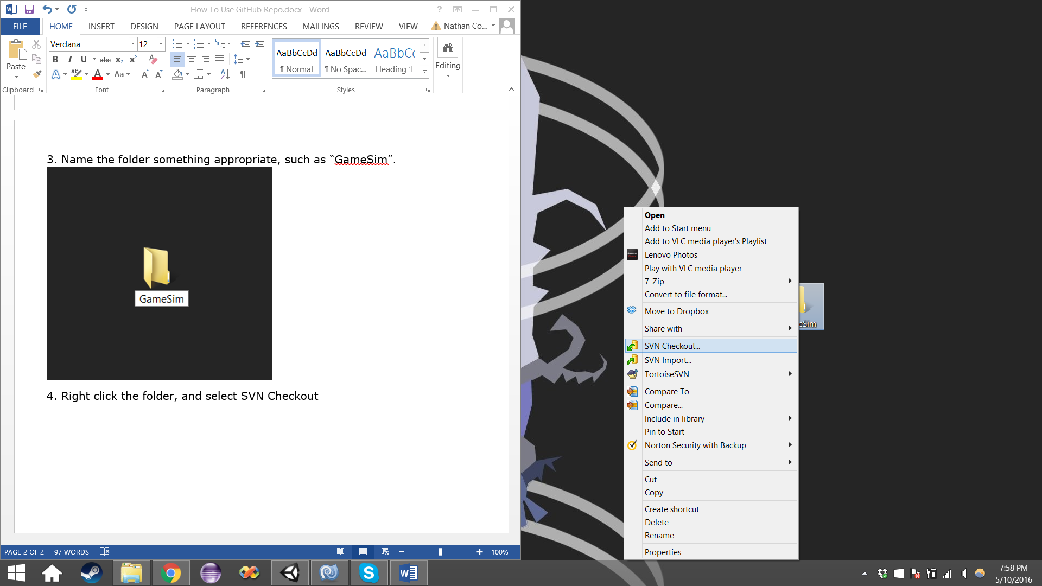

5. Mimic the setting as you see them below. Be sure the URL of repository is exact. The only difference you will have is Checkout directory, which will automatically be set for you. Click OK and proceed to the next screen.

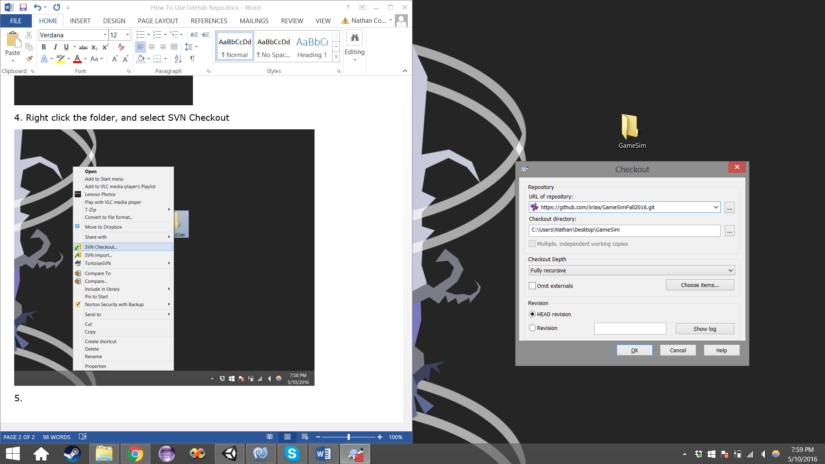

1. You will be presented with an update screen. Allow this screen to sit idle, until you see “Completed” at the bottom of the list, on the left side of the screen. Press okay after the Completed shows up.

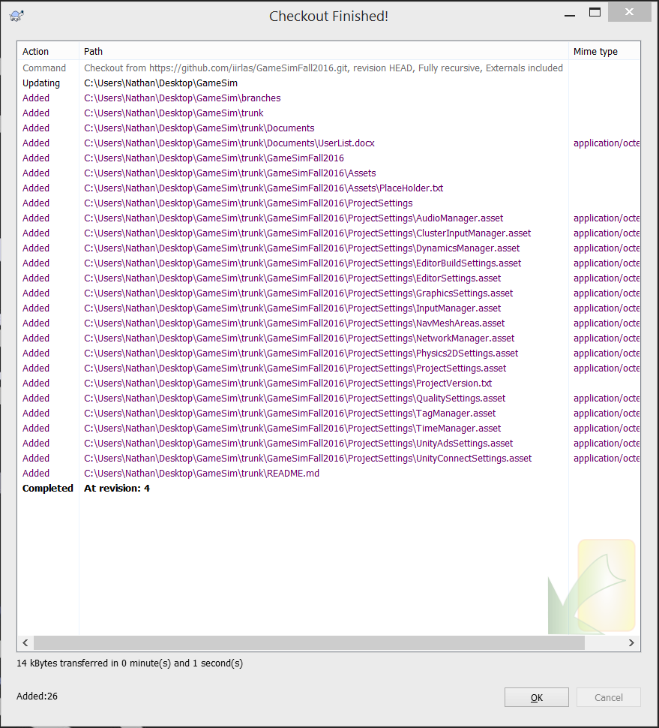

1. You will now be presented with a “versioned” folder. It will look something like this:

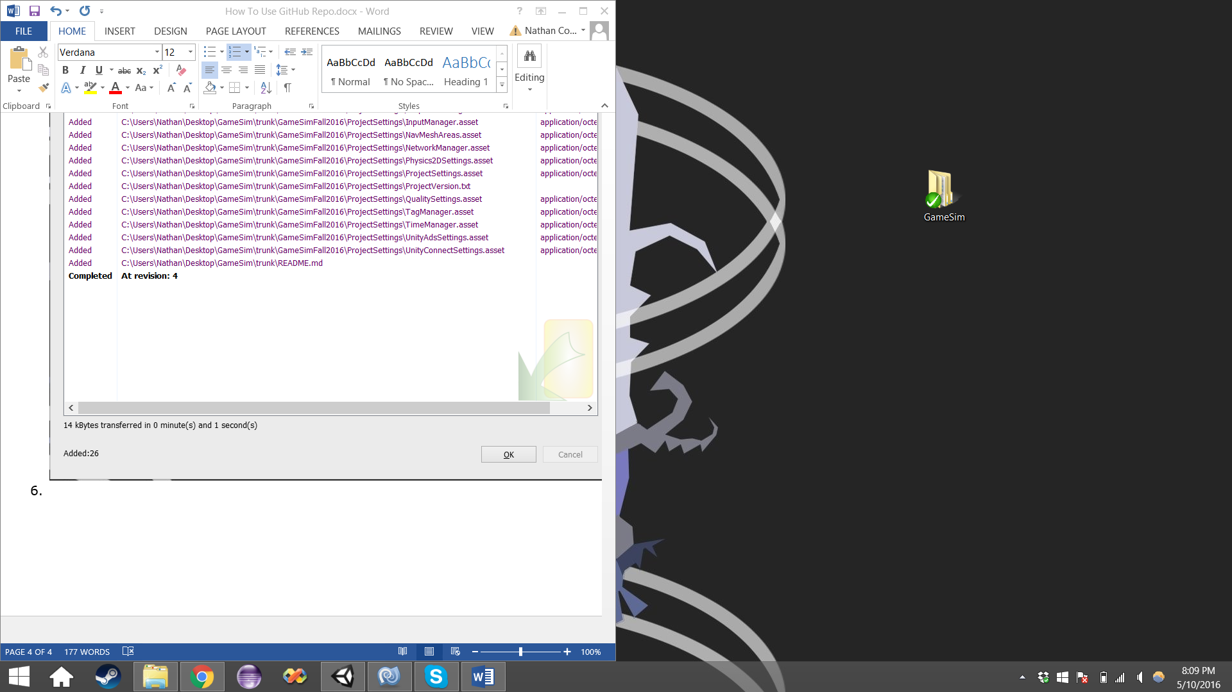

1. Double click the folder, you will be presented with this screen:

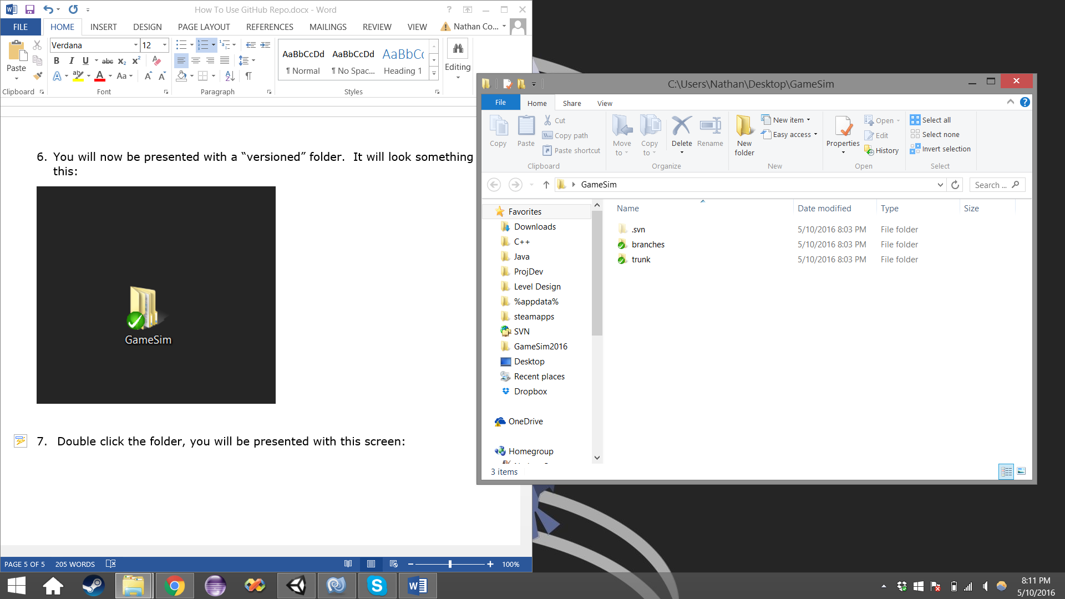

1. We will be working in the “trunk” folder. Double click the “trunk” folder. You will be presented with this screen. The folder “GameSimFall2016” contains an example unity project. Open the “Documents” folder.

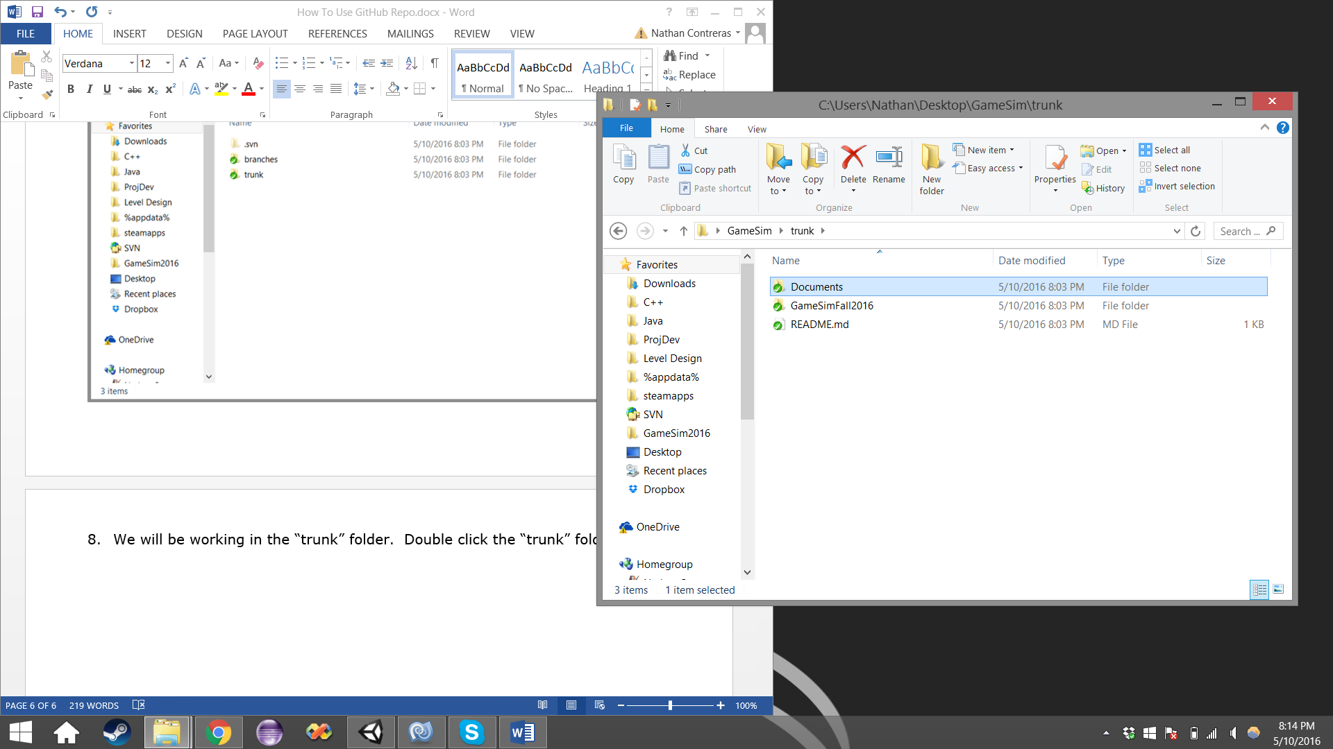

1. You will be presented with this screen below. “UserList.docx” contains a list of people who have successfully completed this tutorial. We will edit this document and add you to the list, please open the document now.

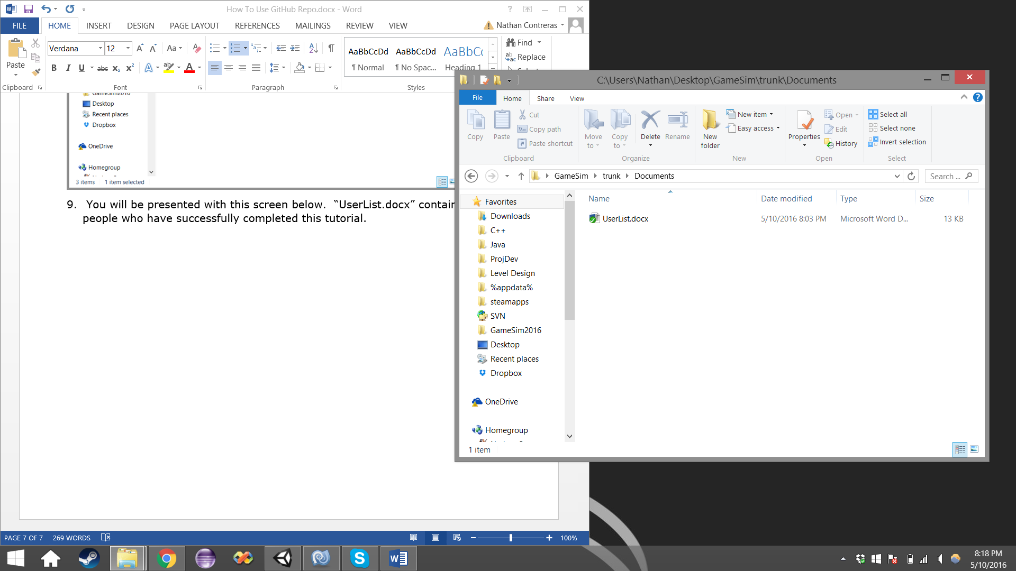

10. Add your name to the list. This is pretty self-explanatory and shouldn’t require an image.

11. Save the changes made to the list, close the word document, and return to the folder. You will notice that there is now a little red exclamation point instead of a green checkmark.

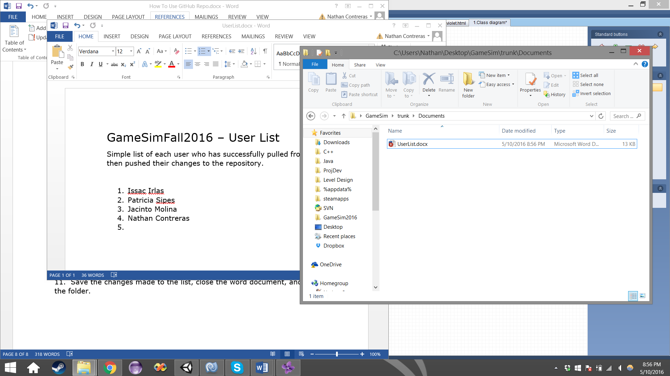

12. Right click the file, and click on “SVN Update”. This will ensure you have the latest version of a file.

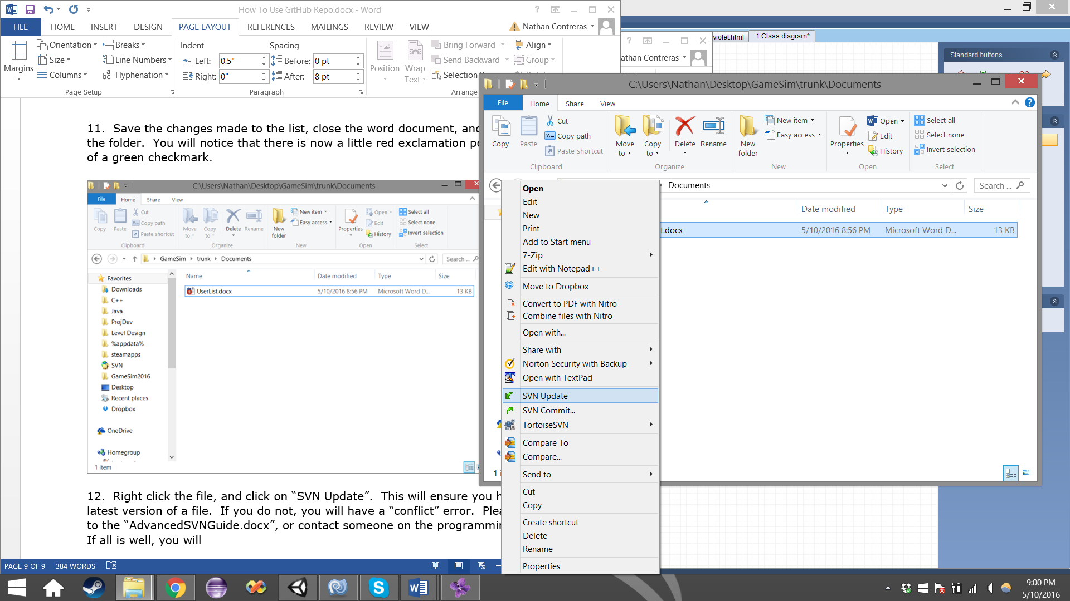

13. If you do not, you will have a “conflict” error. Please refer to the “AdvancedSVNGuide.docx”, or contact someone on the programming team.

If all is well, you will presented with a “Completed” at the bottom left of the list. Click OK.

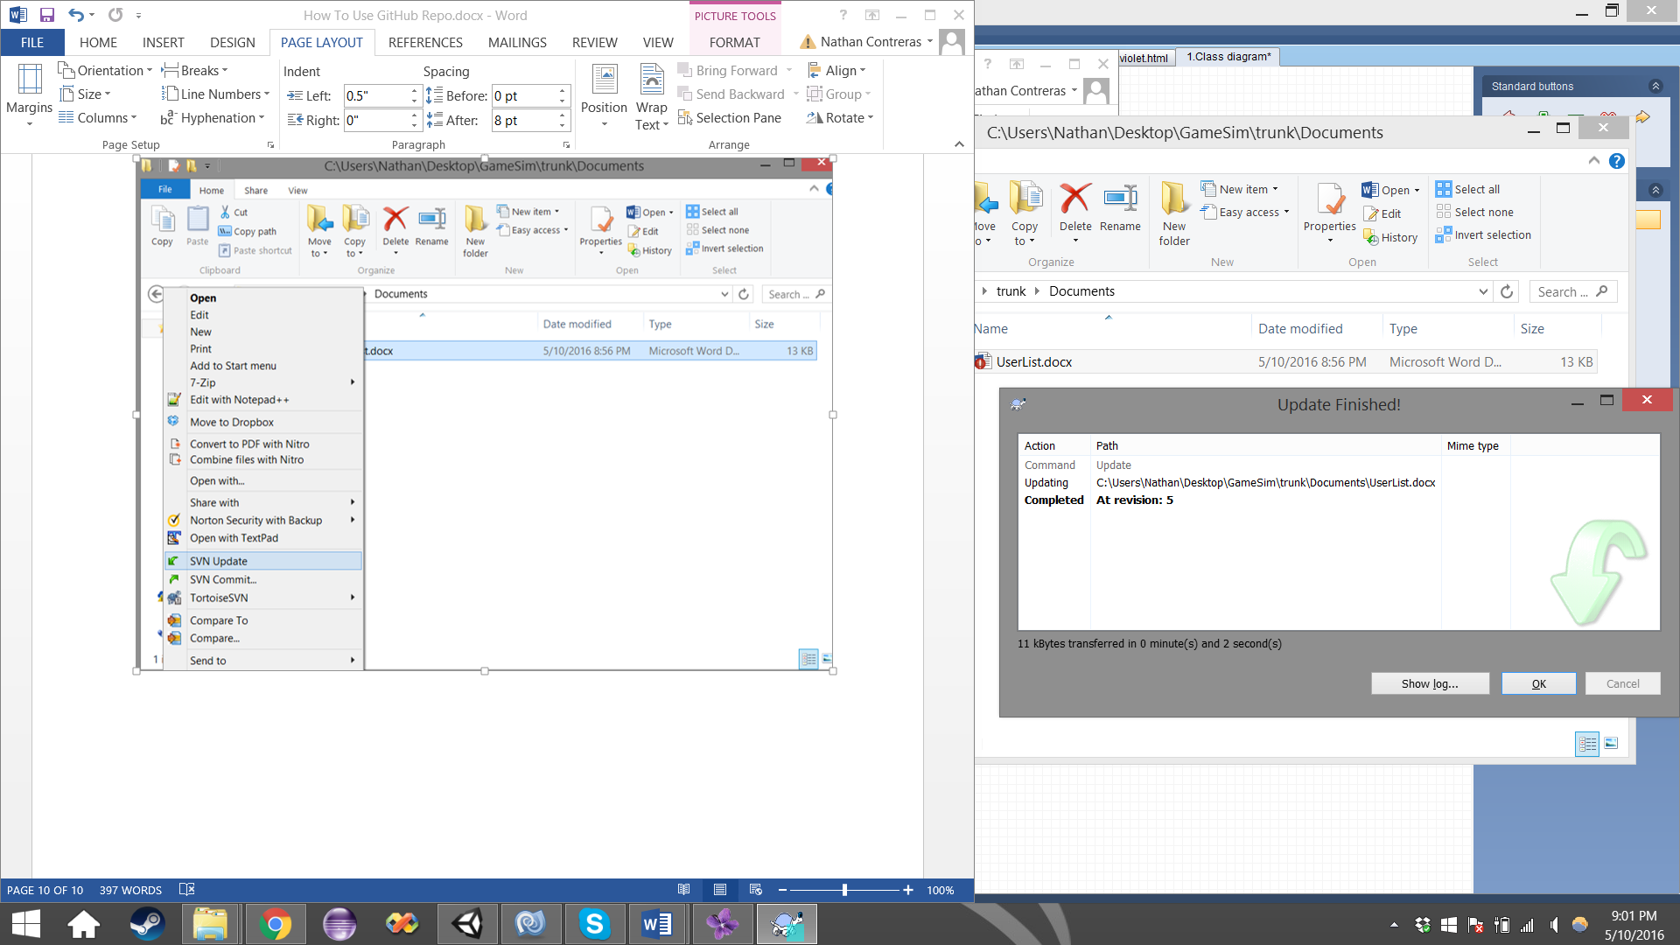

14. Right click the file, and select “SVN Commit”.

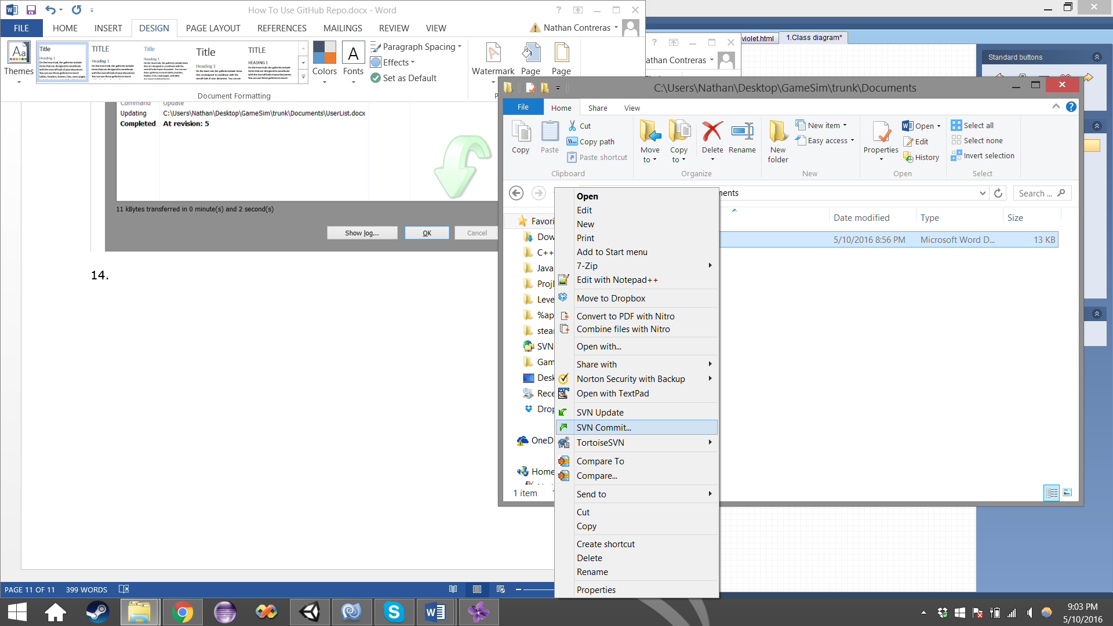

15. You will be presented with this pop-up screen. Underneath the “Recent messages” button, there is a text field. ANYTIME you commit a file, you must attach a comment of some form, follow the example shown below, using your Initials, and the same/similar message. Click OK.

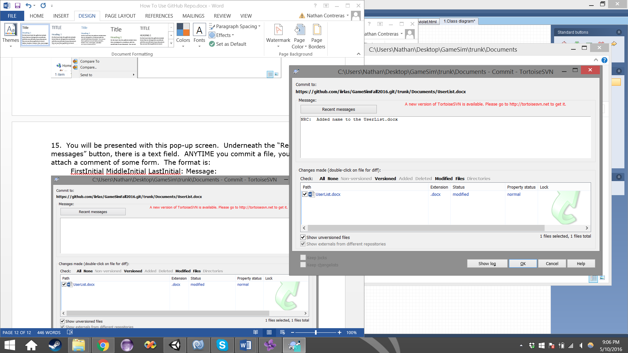

16. You will be presented with the Commit screen. When you see “Completed” in the bottom left of your list, hit OK. If you receive an error, please look at the “AdvancedSVNGuide.docx” guide, or inform one of the programmers.

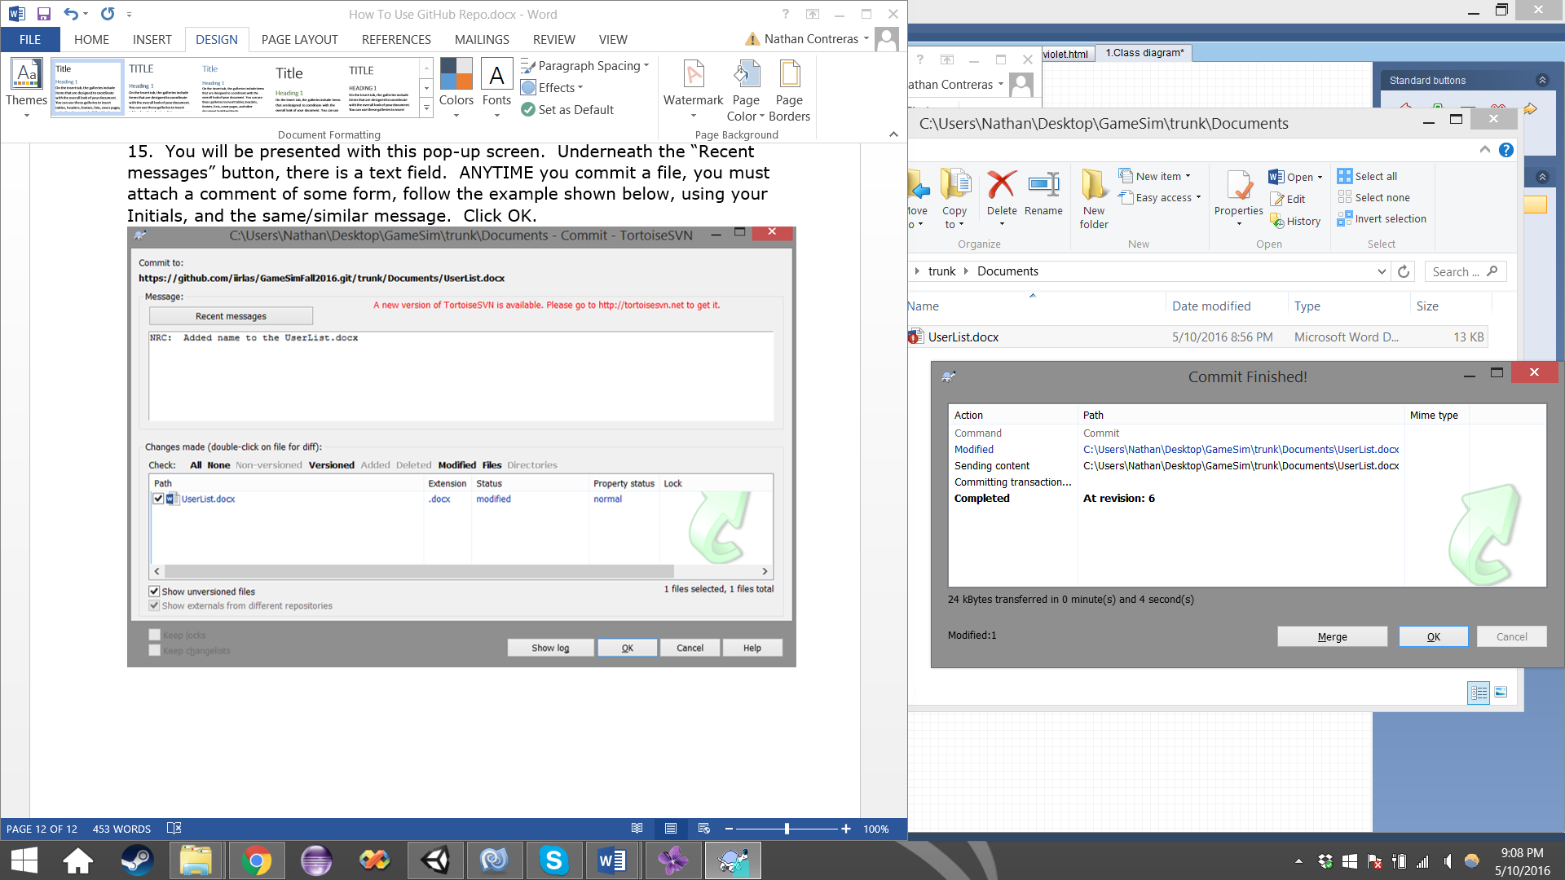

17. Congratulations, you’ve successfully modified an existing file!

**SECTION 2: Adding a new folder and file:**

Locate your existing GameSim (or similarly named) folder.



Right click the folder, and select “SVN Update”, click OK after the update. If there is a conflict, check the advanced guide, or contact a programmer.

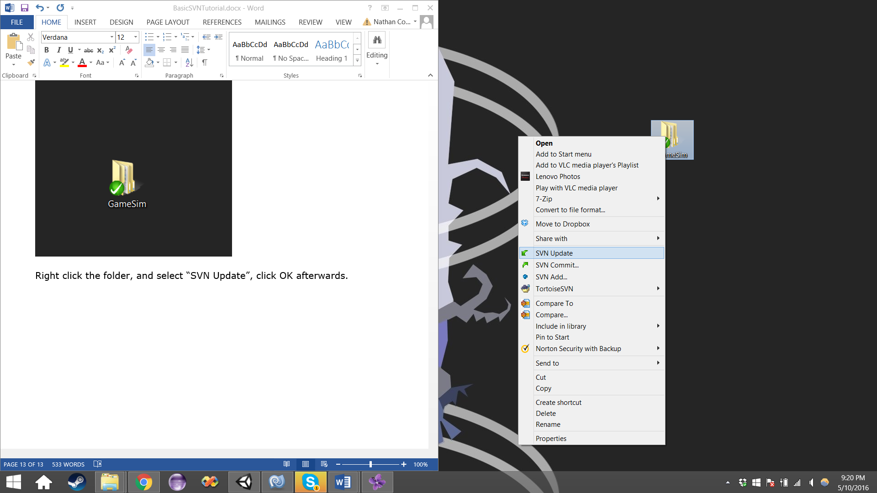

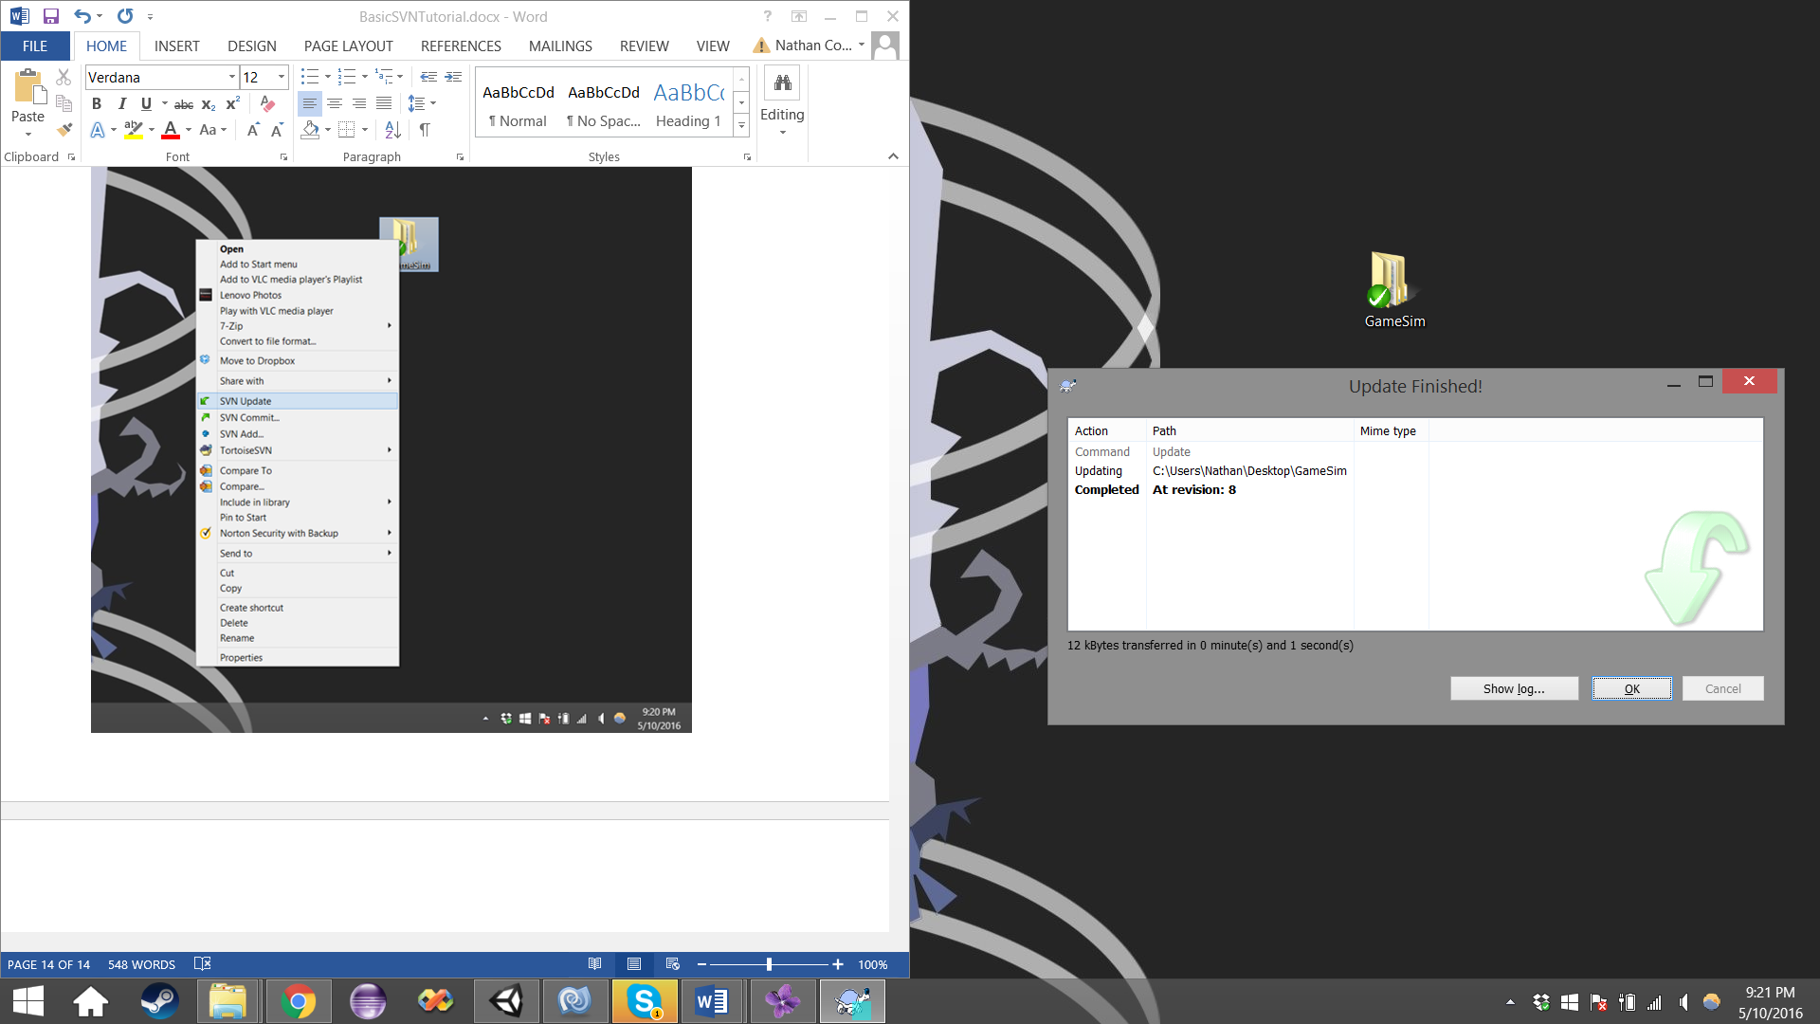

Open up the folder, and navigate your way to the Sandbox folder. You will likely see a couple folders inside.

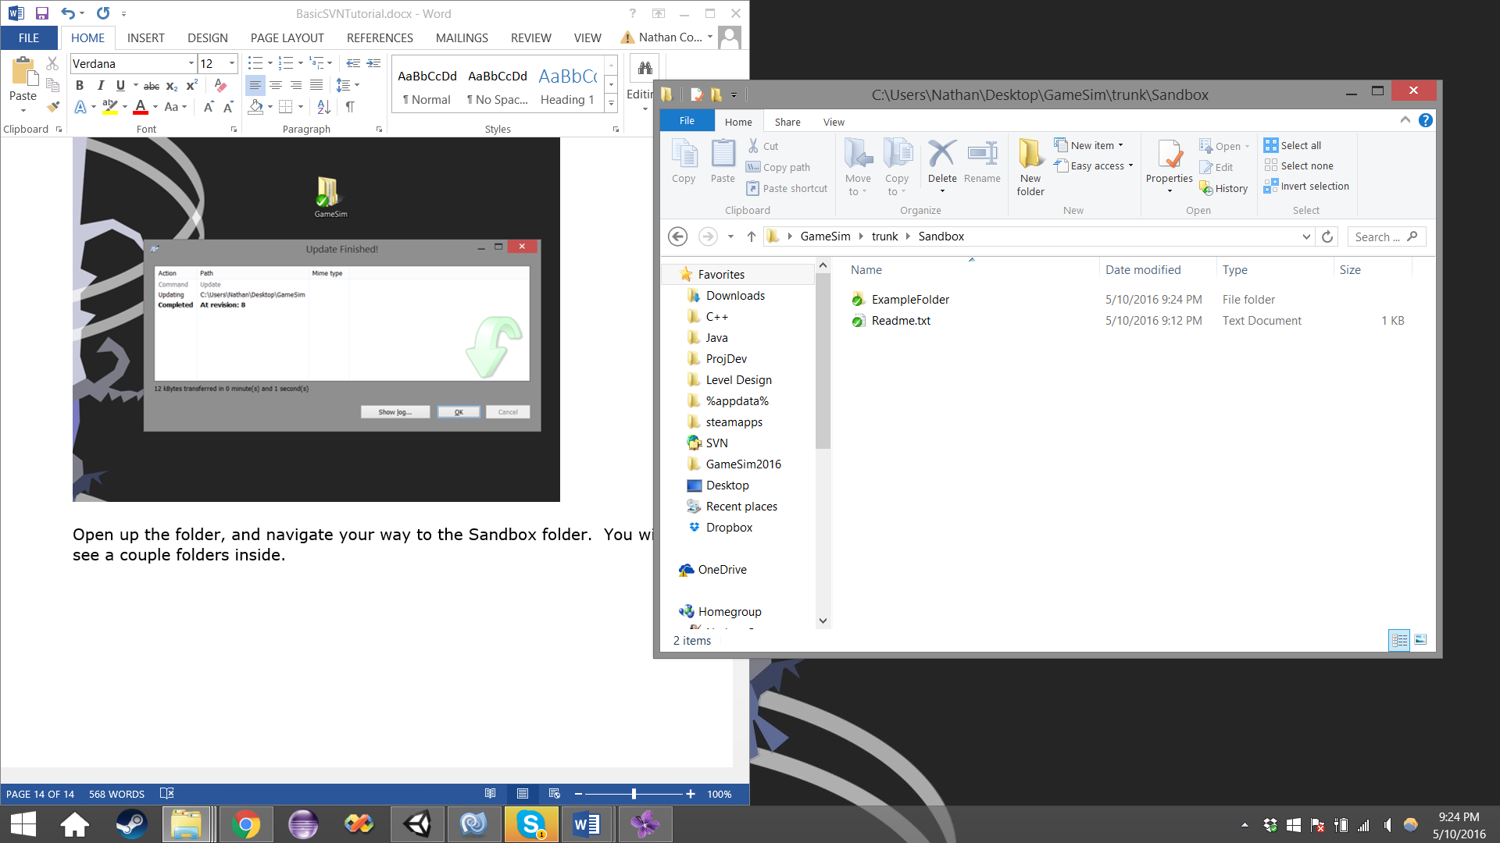

Right click in the white space, and select New, then select Folder.

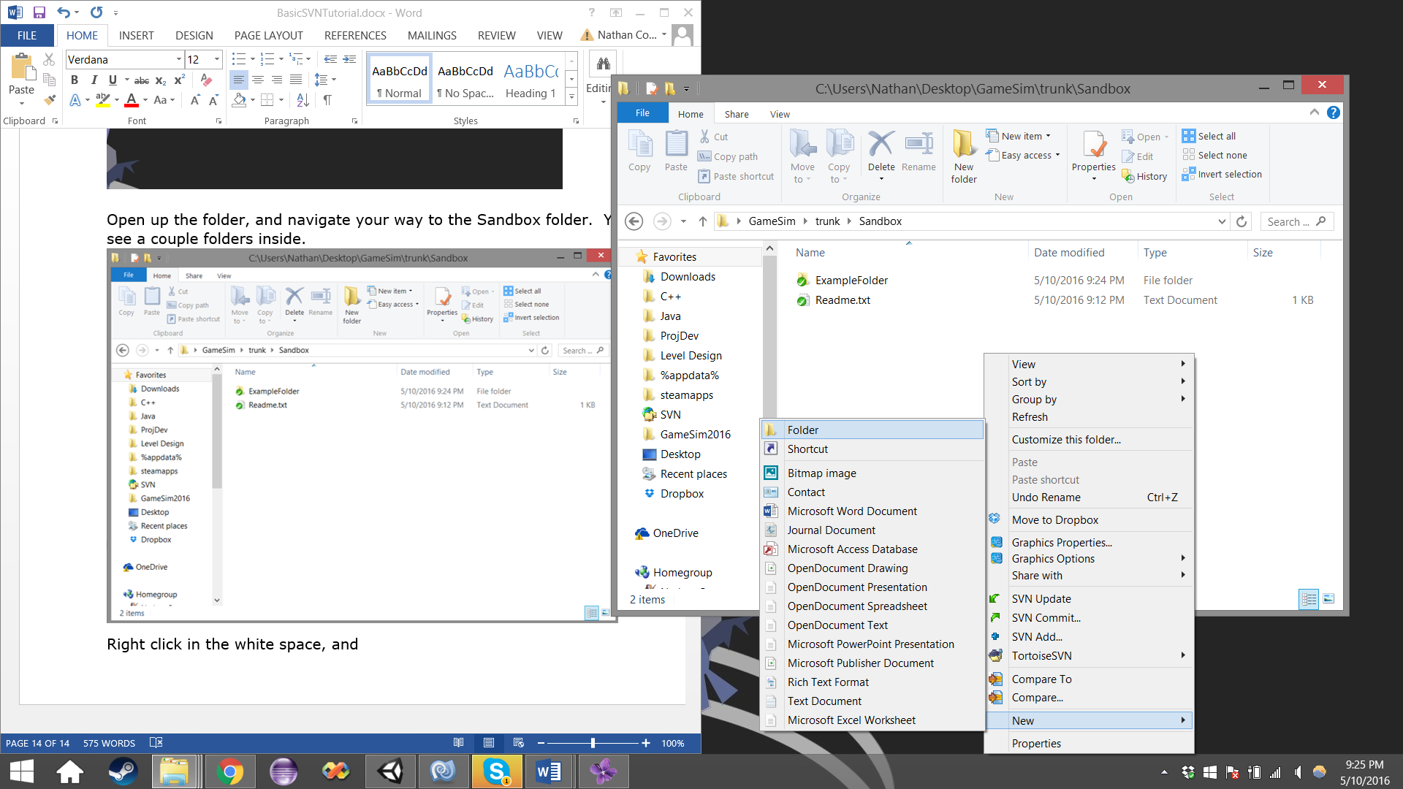

Rename the folder to something, preferably your name or nickname.

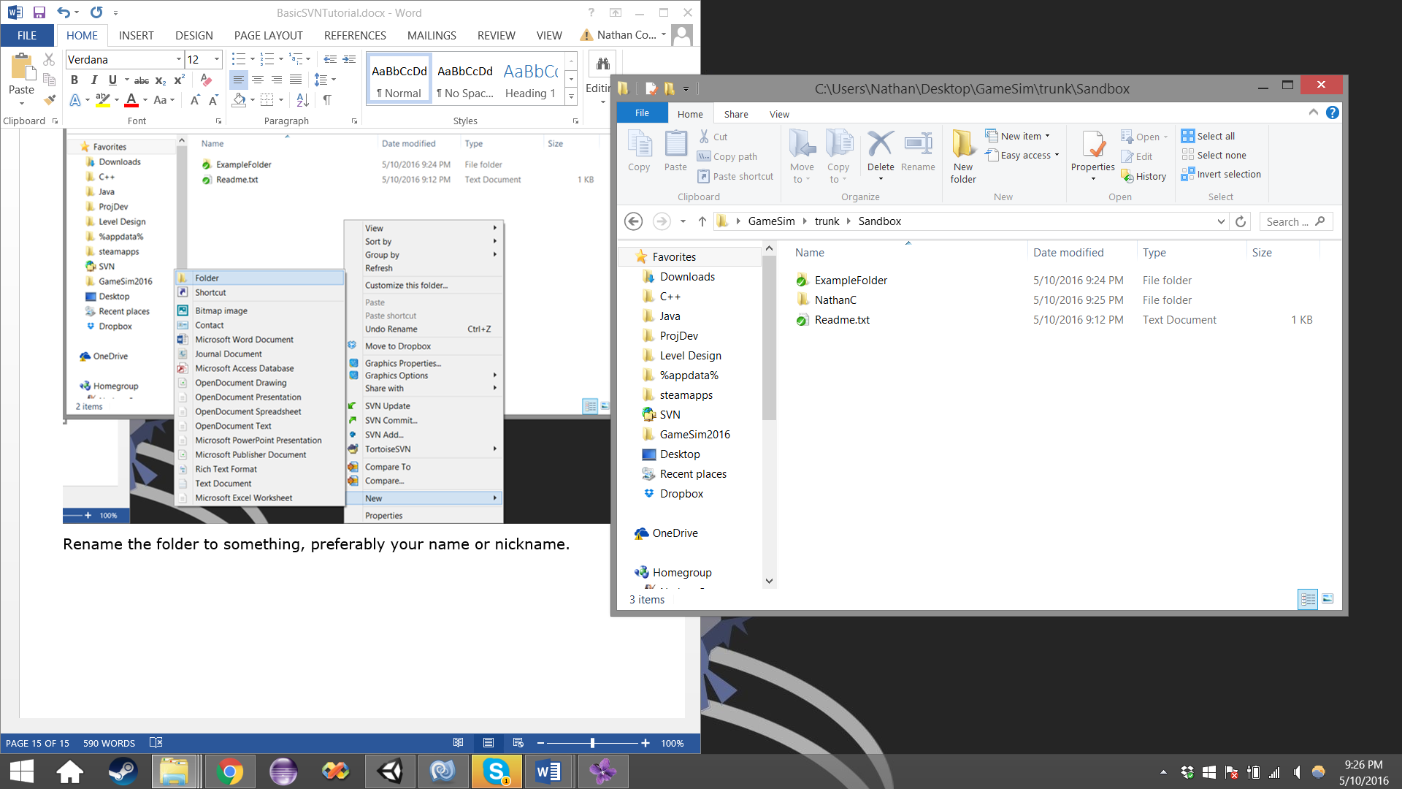

If we tried to add the folder to the repository at this point, we would get an error, because GitHub does not like empty folders. So we will need to add an item into your folder. Open the folder you just added. Right click in the white space and select New, and then select text document.

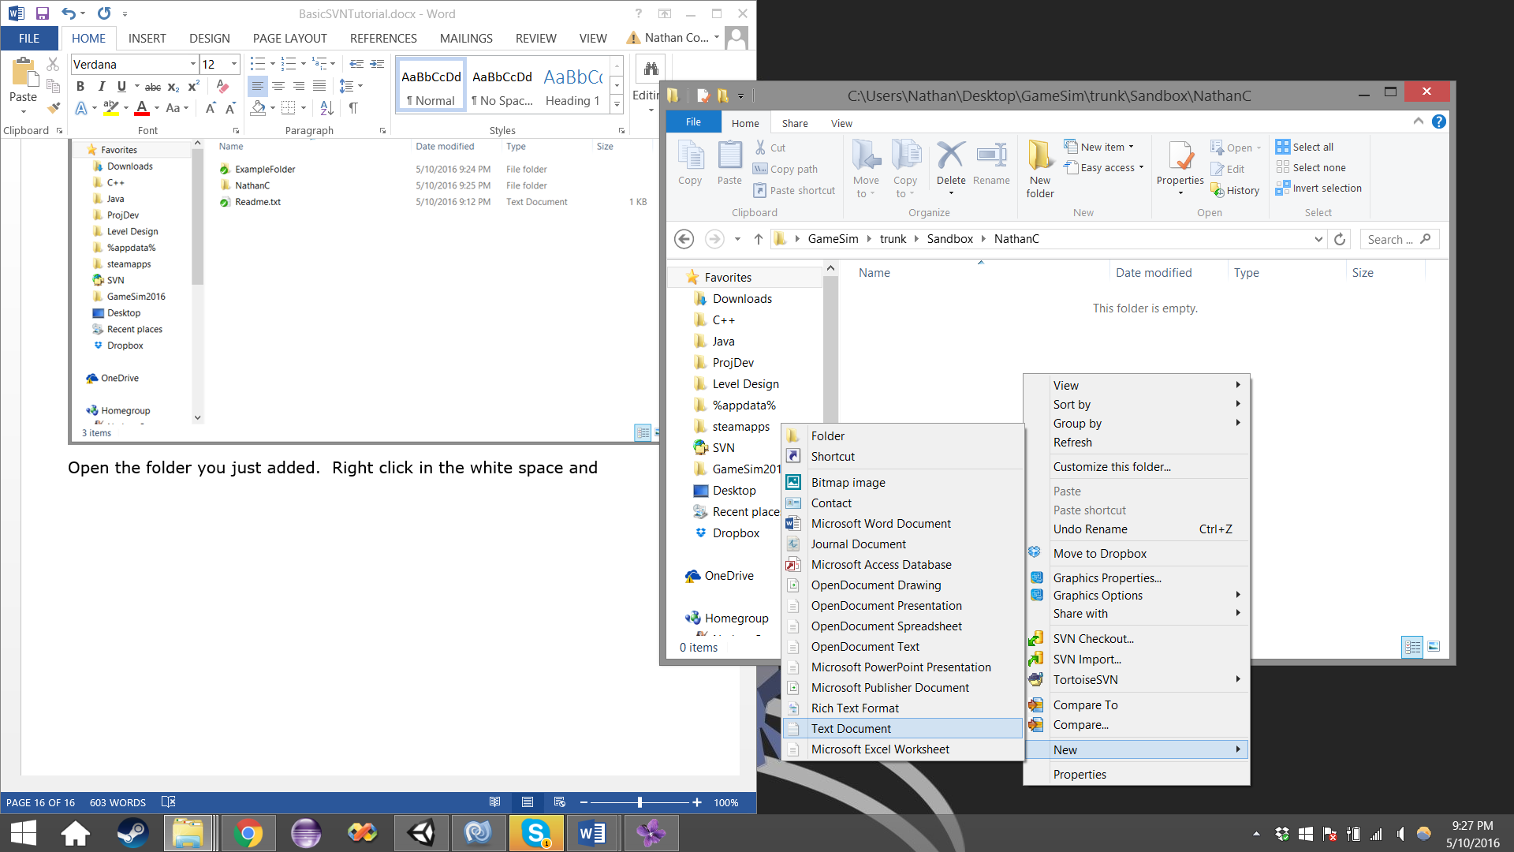

Rename the text document to “HelloWorld”. Right click the file, and select “SVN add”

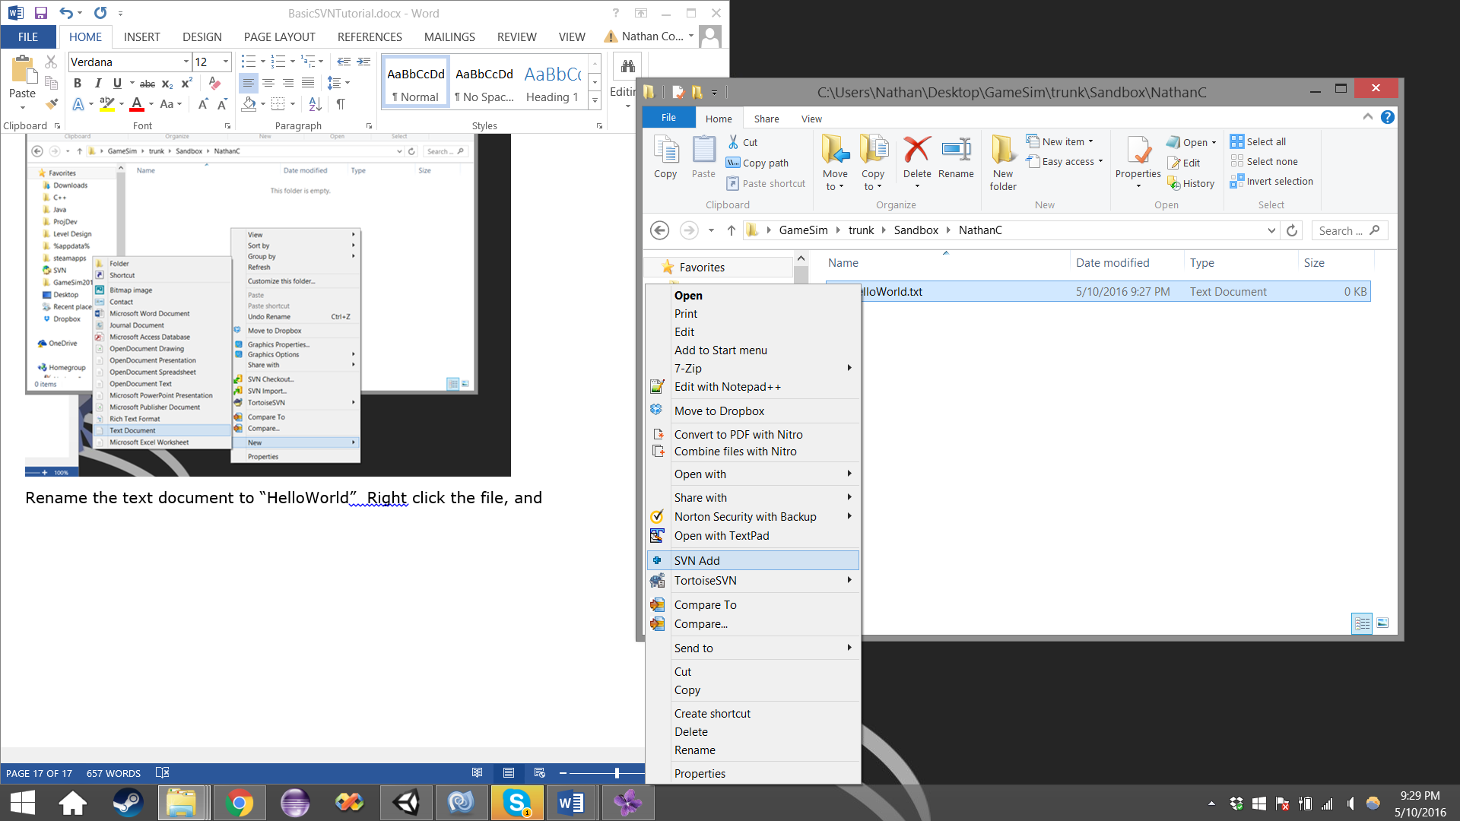

The file has now been indexed into the repository, along with its containing folder. However, this is just letting the repository know it should expect a file and folder soon. Next we need to commit the file in order to complete its addition. We need to go up a level to the previous folder. Following that, we will right click our folder, and click “SVN Commit”. Enter a comment into the text field and click okay.

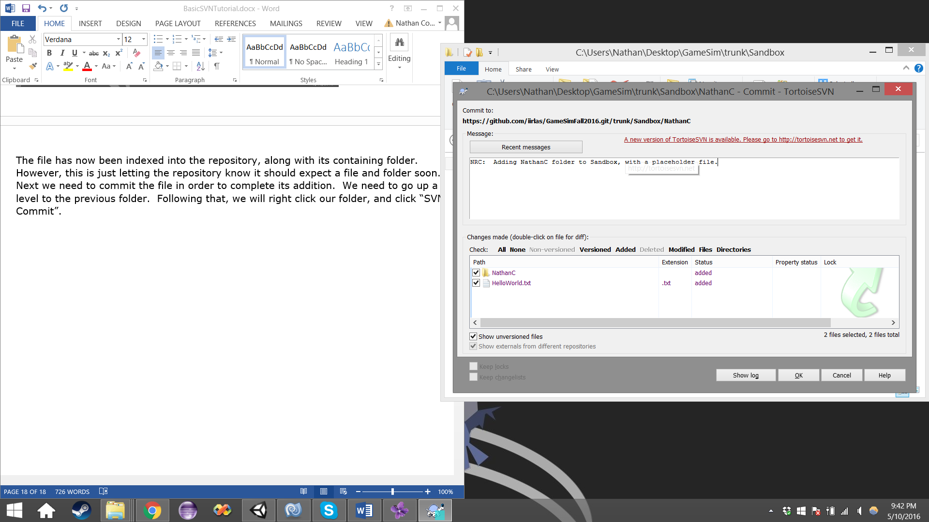

Congratulations! You have successfully added a new folder, and file to the repository. Once again, if you run into any conflicts, check out the advanced guide, or contact a programmer.

